CUSTOMER JOURNEY

Date: 19-11-2022

Team ID: PNT2022TMID17212

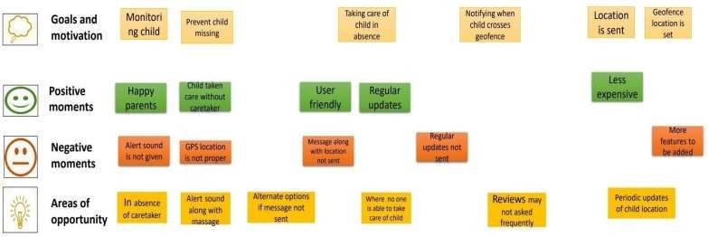Topic: IoT Based safety gadget for child safety monitoring and notifications.

